THE NARRAGANSETT TIMES
Apprenticeship teaches the ins and outs of fishing
KENDRA GRAVELLE. Jun 2, 2018
http://www.ricentral.com/narragansett_times/apprenticeship-teaches-the-ins-and-outs-of-fishing/article_05823620-64dd-11e8-861a-e7652152490a.html
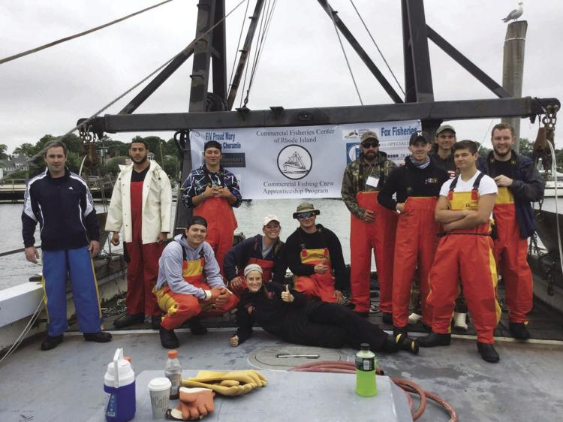

Applications are currently being accepted for the four-week Commercial Fisherman Apprenticeship Program. Participants will learn the ropes of the commercial fishing industry and may even be offered a job upon completion of the program. Pictured: participants of last year’s pilot program.

NARRAGANSETT—In an effort to attract more young people to the fishing profession, an apprenticeship program based out of Point Judith with courses in Kingston will show participants all it takes to be in the commercial fishing industry.
Now in its second year, the four-week Commercial Fisherman Apprenticeship Program was created to prepare young people for careers in New England’s demanding but rewarding fishing industry. A collaboration between Commercial Fisheries Center of Rhode Island (CFCRI) and the University of Rhode Island, the program is funded fully through Real Jobs Rhode Island.
“There’s a desperate need for new crew members,” explained Fred Mattera, executive director of CFCRI. “In order to sustain this into the future we need youth.”
Workers in the fishing industry are aging, Mattera said, adding that the average age for Rhode Island’s fishermen today is close to 50 years old.
Mattera said an overall reluctance by young people to become fishermen has contributed to a decline in men and women choosing to enter into the commercial fishing industry. He said because pay depends on fishing conditions, that uncertainty tends to scare off some prospective fishermen.
“There’s times when you can make a lot of money,” he said, “but you just don’t know what’s going to happen in fishing.”
He said seasickness can also get the best of some.
“I’d say 50, 60 percent of those who come down are so seasick they can’t fish,” he added. “So there’s also a reluctance to take someone on as a greenhorn.”
But through the apprenticeship program, Mattera said aspiring fishermen will receive proper training in things like safety before they’re taken out to sea.
“And we see, are you capable of doing this?” he said, adding that although last year a couple apprentices experienced seasickness, they got over it and found out they would do better on a small boat close to shore.
Mattera is a retired commercial fisherman with 40 years of experience in the industry. As one of the founders of the apprenticeship program last year, this year he is excited to expand it after its successful test-run.
Of 12 apprentices who participated in 2017, 10 are working in the industry today. And this year—with more funding available—16 individuals will be selected for participation in the program.
The program will take place in both Kingston and at Point Judith and will include training in things like boat maintenance, safety, CPR and first aid and how to mend nets and tie knots. Classroom sessions will also include lessons on fishing as a business, Rhode Island fisheries management and regulations, cooperative research, data collection, species identification and ethics of responsible fishing practices.
Participants will also have the opportunity to choose from a set of career pathways, which include rod and real-head boat and private charter boats, scalloping, gillnetting, lobster and fish pots and trawling.
The application process for the program is fairly rigorous, Mattera said. Successful applicants will either have graduated high school or hold a GED (General Equivalency Diploma), will be able to pass drug screenings, will work well in a team and will be physically able to do the work.
But above all else, Mattera said he’s looking for young men and women who can demonstrate their commitment to joining the profession.
“That’s the most important,” he added. “This isn’t something to come out and do for the summer and then go away—it’s a lot of work and a lot of effort and a lot of time away.”
Mattera is especially keen on hiring veterans. He said he admires their discipline and work ethic.
“I love what I’ve seen in the fishermen I do know that are veterans,” he said, adding that veterans in the apprenticeship program can also receive G.I. benefits.
Upon completion of the program, all apprentices will receive a $1,000 stipend and may even be offered a job. Participants will also receive gear and course material, and will be given a daily lunch stipend through the program’s duration.
And while fishing is a demanding profession, it can also be quite a rewarding one.
“I watch these kids because I’ve minted them,” Mattera said. “I see them on Facebook and Instagram and I see the pictures—I see the pictures of them holding fish. I see the pictures of them in front of a sunset or sunrise. I see that they’re so excited because they just had a nice trip and they caught a lot of fish and they made money.”
To Mattera and many others, those experiences make the long hours, possible seasickness and any other uncertainties surrounding the job well worth it.
“When you see this pride that comes with, ‘wow, I’m fulfilling a dream - I’d never be able to see and experience this,’” he continued, “you go out there and you spend a beautiful starry night and you’ve got dozens and dozens of dolphins swimming all around the boat—there’s nothing like it.”
Applications for the program can be found online at cfcri.org, and should be submitted as soon as possible.

